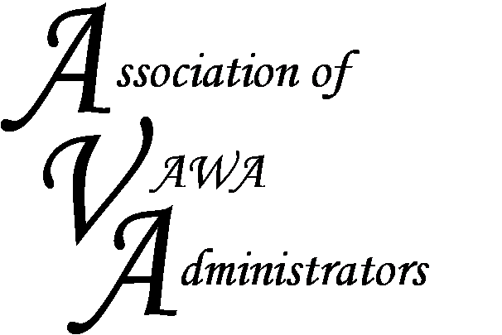

To encourage and facilitate mutual support, awareness and cooperation
among states and territories administering Violence Against Women Act grants.

Peer-to-Peer Regional Meeting

Phoenix, Arizona
January 28, 2016
8:30 am – 4:00 pm

AGENDA

8:30 - 8:45 am Welcome and Introductions
8:45 - 9:45 am Tracking category percentages
9:45 - 10:30 am Funding strategies and meeting the statutory set-asides
10:30 - 10:45 am Morning Break
10:45 - 11:30 am Carrying monies over year to year to fill in gaps in funding areas;
11:30 am - 12:30 pm Lunch
12:30 - 1:15 pm Managing returned monies
1:15 - 2:00 pm Reporting challenges (including close-out reports) and red flag reports
2:00 - 2:15pm Afternoon Break
2:15 - 3:00 pm Budgeting
3:00 - 3:45 pm Monitoring the challenging subgrantee program
3:45 to 4:00 pm Wrap-up

