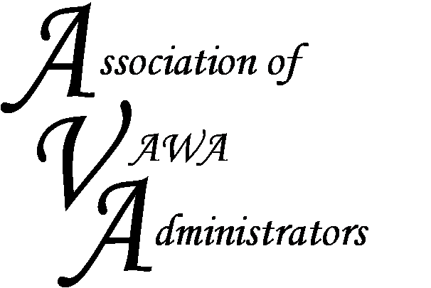

To encourage and facilitate mutual support, awareness and cooperation among
states and territories administering Violence Against Women Act formula grants

Membership Registration Form
July 1, 2016 - June 30, 2017

Agency/Organization:

STOP Program Primary Contact:
Title/Position:
Address:
City, State, Zip
Phone
Email Address:

STOP Program Secondary Contact
Title/Position:
Address:
City, State, Zip
Phone
Email Address

Other funds your agency administers as issued by OVW or other funders:

Please list below any additional staff that you would like to have added to the AVA Listserv.

Staff Name: | Title: | Email: | Phone Number:

If you have any questions or concerns, please contact Dorene Whitworth, AVA Executive Director, or any of the AVA Board Members. Also, please mail registration forms and fees to

Dorene Whitworth, Executive Director
Association of VAWA Administrators
2325 Peavine Valley Road
Reno, Nevada 89523
Phone: 775-721-4691
Email: Dorene@AVAdministrators.org

