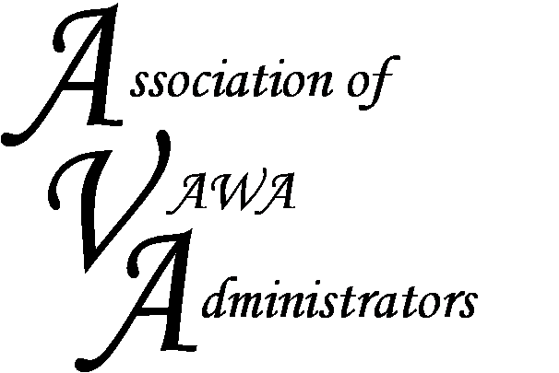

To encourage and facilitate mutual support, awareness and cooperation
among states and territories administering Violence Against Women Act grants

Membership Registration Form
July 1, 2015 - June 30, 2016

Agency/Organization:
STOP Program Primary Contact:

Title/Position:

Street Address:

City: State/Territory: Zip Code:

Phone: Business Cell: Fax:

Email Address:

Other funds your agency administers as issued by the Office on Violence Against Women (OVW):

Other Federal funding sources your agency administers (examples include VOCA, BYRNE, FVPSA, etc.):

Please list below any staff that would like to join the VAWA Administrators Listserv.

Staff Name: | Title: | Email: | Phone Number:

If you have any questions or concerns, please contact Dorene Whitworth, AVA Executive Director, or any of the AVA Board Members. Also, please mail registration forms and fees to

Dorene Whitworth, Executive Director
Association of VAWA Administrators
1788 Colavita Way
Reno, Nevada 89521
Phone: 775-721-4691
Email: Dorene@AVAdministrators.org

To encourage and facilitate mutual support, awareness and cooperation
among states and territories administering Violence Against Women Act grants
AVA Membership Dues
July 1, 2015 - June 30, 2016

Thank you for your membership with AVA! Please have your dues to us by September 1, 2015. Using the dues schedule below, please make checks payable to “Association of VAWA Administrators”. We can also accept electronic payments from your state (please contact Dorene Whitworth to set this up if you have not done so previously); however, we are unable to accept credit cards at this time. The AVA EIN is 27-3187966.

Amount Enclosed:

Check Number:

Dues Structure: Below are the registration dues for the membership period of July 1, 2015 – June 30, 2016.
A five-bracket structure based on population was used to determine dues.

AVA Dues Schedule by State/Territory

 | AVA Dues  Amount |  |  | AVA Dues  Amount |  |  | AVA Dues  Amount
Alabama | $2,250 |  | Kentucky | $2,250 |  | Northern Mariana Islands | $500
Alaska | $750 |  | Louisiana | $2,250 |  | Ohio | $3,000
American Samoa | $500 |  | Maine | $1,500 |  | Oklahoma | $2,250
Arizona | $2,250 |  | Maryland | $2,250 |  | Oregon | $1,500
Arkansas | $1,500 |  | Massachusetts | $3,000 |  | Pennsylvania | $3,000
California | $3,000 |  | Michigan | $3,000 |  | Puerto Rico | $2,250
Colorado | $2,250 |  | Minnesota | $2,250 |  | Rhode Island | $750
Connecticut | $1,500 |  | Mississippi | $1,500 |  | South Carolina | $2,250
Delaware | $750 |  | Missouri | $2,250 |  | South Dakota | $750
District of Columbia | $750 |  | Montana | $750 |  | Tennessee | $2,250
Florida | $3,000 |  | Nebraska | $1,500 |  | Texas | $3,000
Georgia | $3,000 |  | Nevada | $1,500 |  | Utah | $1,500
Guam | $500 |  | New Hampshire | $1,500 |  | Vermont | $750
Hawaii | $750 |  | New Jersey | $3,000 |  | Virgin Islands | $750
Idaho | $1,500 |  | New Mexico | $1,500 |  | Virginia | $3,000
Illinois | $3,000 |  | New York | $3,000 |  | Washington | $2,250
Indiana | $3,000 |  | North Carolina | $3,000 |  | West Virginia | $1,500
Iowa | $1,500 |  | North Dakota | $750 |  | Wisconsin | $2,250
Kansas | $1,500 |  |  |  |  | Wyoming | $750

