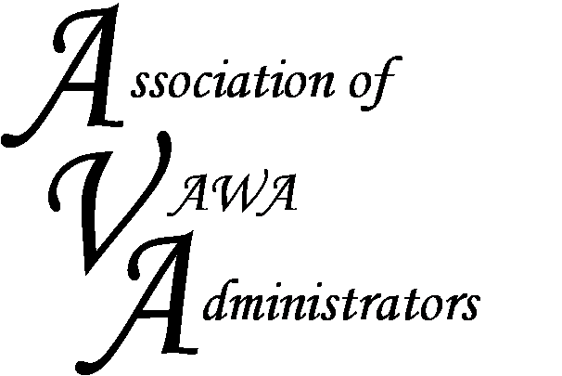

To encourage and facilitate mutual support, awareness and cooperation among
states and territories administering Violence Against Women Act grants.

Semi-Annual Board Meeting Summary
October 29-30, 2015
Chicago IL

The AVA Board of Directors held its board retreat in Chicago in late October. The benefit of this retreat is that it gives the AVA Board members time away from their offices to focus solely on addressing needs of STOP Administrators and furthering AVA’s mission. We reviewed the input received from Administrators at the annual STOP conference and discussed interactions we’ve had with other national organizations.

The primary outcomes of this meeting are as follows:

- AVA will hold regional peer-to-peer meetings to give Administrators time to discuss the daily responsibilities of managing their STOP grant, e.g. identifying gaps in funding, reallocations, rolling monies forward year-to-year, monitoring, etc.

- AVA will begin distributing packets of information to new Administrators which includes some history of AVA and the STOP program as well as information on the Muskie forms, red flag reports, and GMS, etc. The packet will also provide a list of commonly used acronyms.

- AVA will reach out to their national contacts working on VAWA reauthorization to ensure Administrators needs and concerns are heard during any changes affecting administration of the VAWA formula grant programs.

The AVA Board works hard to address your needs and concerns. Please feel free to contact us with your comments and/or suggestions.

