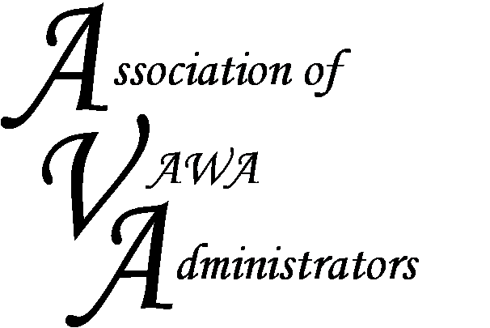

To encourage and facilitate mutual support, awareness and cooperation
among states and territories administering Violence Against Women Act grants

AVA Annual Meeting and
Board Elections

AGENDA

Wednesday, April 29, 2015
7:30 – 8:45 am
Crown Plaza Jacksonville Riverfront Hotel
“Duval” Room

- Welcome & Introduction of the AVA Board

- Report from AVA President

- Report from AVA Treasurer

- AVA Board Elections – nominations from the floor

- New Website Preview

- Open Forum Discussion – review survey results and set future goals for AVA

- Introduce new AVA Board Members

- Closing Remarks

