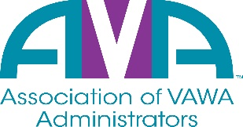

To encourage and facilitate mutual support, awareness and cooperation among
states and territories administering Violence Against Women Act formula grants.

SAVE THE DATE – June 20th, 2024
AVA Annual Meeting – 2:00pm – 3:30pm EST
AVA’s Annual Meeting will take place this year, via webinar. Please join us as we provide:
- Updates and opening remarks from AVA’s Board President
- A review of AVA’s FY23-24 budget with AVA’s Finance Committee
- An update from AVA’s Executive Director on the accomplishments of FY23-24
- Nominations and Election voting for AVA’s Board of Directors
We are asking that you reserve a 90-minute block from 2:00pm – 3:30pm EST to allow us time to cover everything listed above and to answer any other questions that you may have.
New members will be voted in during the annual meeting webinar.
More information coming soon regarding how to access the webinar.

