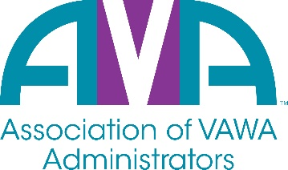
To encourage and facilitate mutual support, awareness, and cooperation among
states and territories administering Violence Against Women Act formula grants.

2023/2024 AVA Board of Directors

Executive Committee Members
President Vice President
Mark Hertweck Amy Baynes
mark.hertweck@ky.gov amy.baynes@tn.gov
502-564-8210 615-532-2988
Kentucky Tennessee

Secretary Treasurer
Gene Nelson TBD
Gene.Nelson@ccvs.vermont.gov TBD
802-241-1250 TBD
Vermont TBD

At-Large Members

Lori Miller Moriah Pease
Lori.miller@ag.iowa.gov mpease@utah.gov
515-725-4130 385-522-6319
Iowa Utah

Laura Russell Tierra Williams
Laura.Russell@dac.state.ok.us tierra.williams@dcjs.virginia.gov
405-264-5008 804-239-8850
Oklahoma Virginia

Laura Quasney Leeana Liska
Laura.Quasney@state.sd.us LiskaLJ@doj.state.wi.us
605-773-4317 608-243-2100
South Dakota Wisconsin

Executive Director

Barry Bryant
avadirectorbb@gmail.com
(919) 588-9615
North Carolina

